LAB 2 – HOST STATIC WEBSITE IN AZURE STORAGE ACCOUNT

1. Create Index.html and error.html in notepad

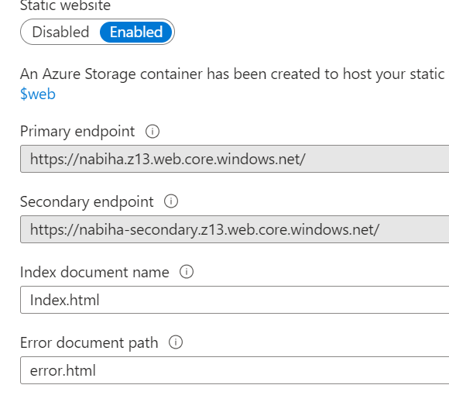

3.

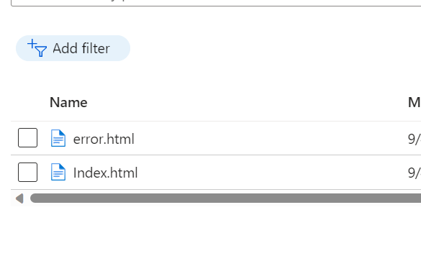

4.

